Milestone 6: Testing the Configuration

Activity 1: Test Mandatory Enforcement
Description
1.Navigate to Incident:
Go to Incident → Create New to open a new Incident form.
2.Set the Impact Field:
Select High for the Impact field. This will trigger the UI Policy and Client Script behaviors you configured earlier.
3.Leave Assigned To Empty:
Do not fill in the Assigned To field. This will test the onSubmit Client Script that prevents saving if Assigned To is missing.
4.Click Submit:
Attempt to save the Incident record.
5.Verify the Result:
- The Incident should not be saved because Assigned To is required when Impact is High.
- An error message should appear, indicating that the Assigned To field cannot be empty.
- Confirm that all UI Policy actions, such as read-only fields or automated urgency updates, are working as expected.

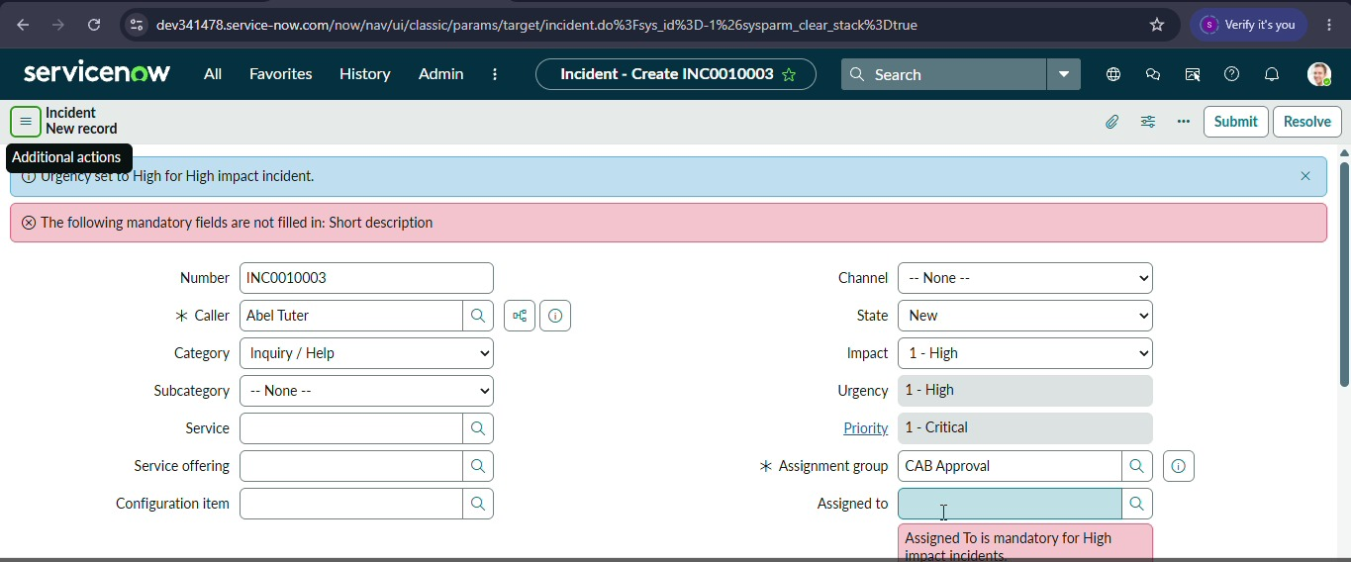

Activity 2: Test Successful Save
Description
1.Fill the Assigned To Field:
Open the Incident form and select a user in the Assigned To field. This ensures the onSubmit Client Script condition is satisfied.

2.Click Submit:
Attempt to save the Incident record.

3.Verify the Result:
- The Incident should be saved successfully without any errors.
- Confirm that all other configured behaviors, such as:
- Urgency auto-setting (from the onChange Client Script)
- Read-only fields (from the UI Policy Action)
- State restrictions (from the onCellEdit Client Script)
are functioning as expected
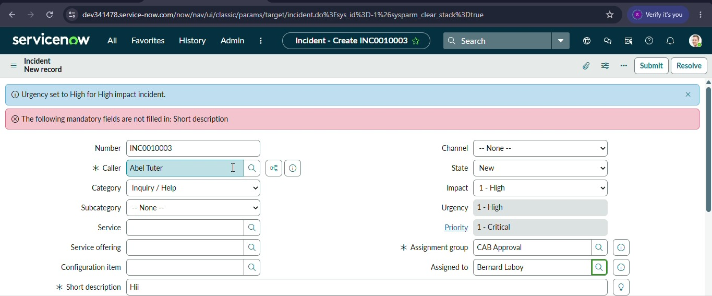

Activity 3: Reverse Condition Test
Description
1.Open an Existing Incident:
Go to Incident → Open and select an Incident where Impact is currently set to High.
2.Change Impact:
Update the Impact field from High to Medium. This will test the Reverse if false functionality of your UI Policy and the behavior of your Client Scripts.
3.Verify the Field Behavior:
- Assigned To should no longer be mandatory.
- Urgency should now be editable, meaning the read-only UI Policy action is reversed.
4.Save the Record:
Click Submit to save the changes. The record should save successfully without errors, confirming that the reverse condition works as intended.
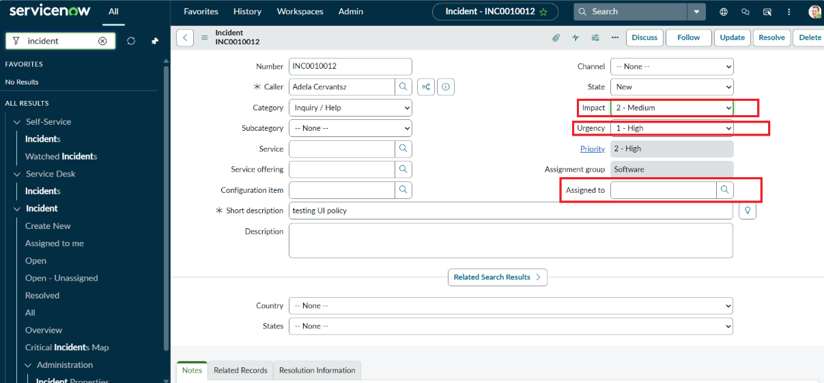

Activity 4: Test List Edit Blocking
Description
1.Navigate to the Incident List:
Go to Incident → All to view all Incident records in a list view.
2.Attempt a List Edit:
- Locate any Incident in the list.
- Double-click the State field to try editing it directly from the list.
3.Verify the Behavior:
- An alert message should appear, indicating that direct changes to the State field are not allowed.
- The State value should remain unchanged, confirming that the onCellEdit Client Script is working correctly.

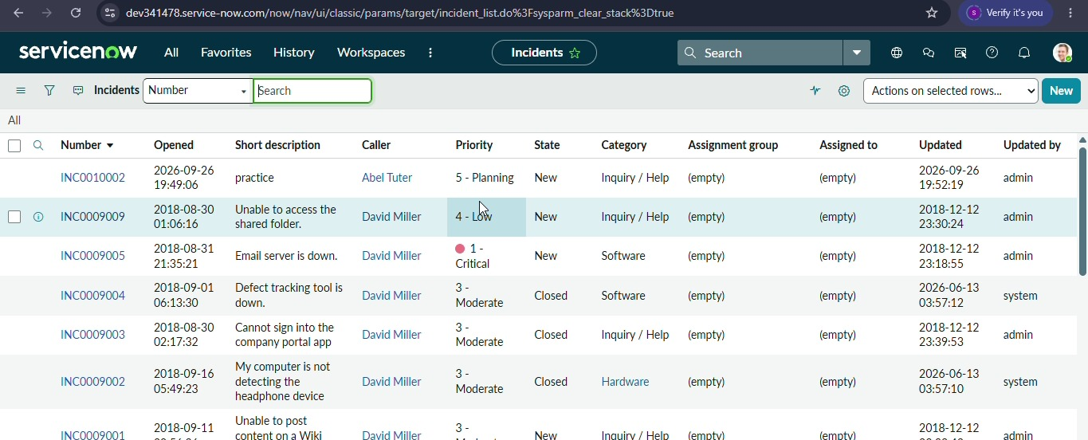

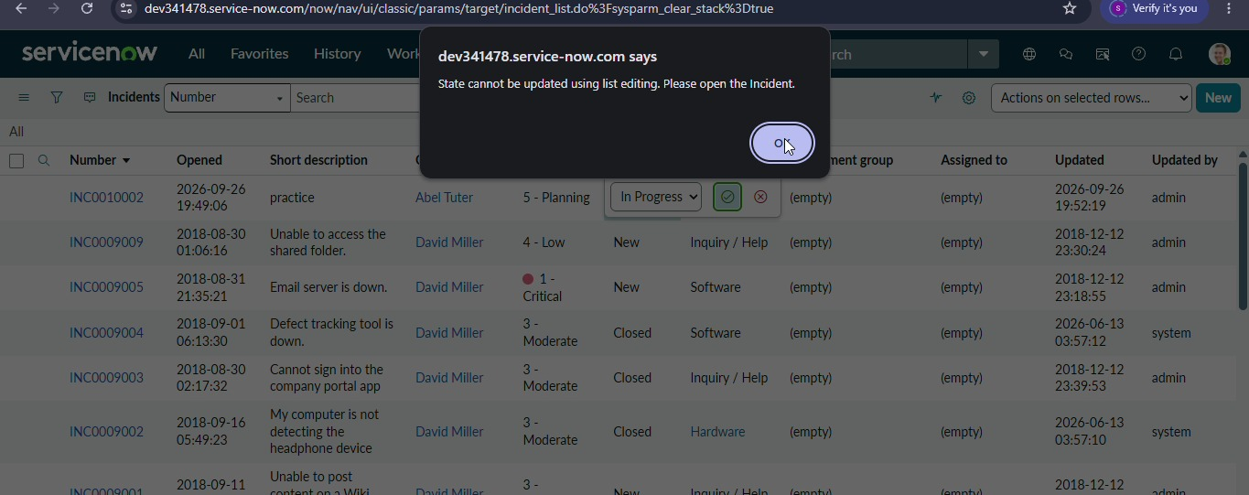

Activity 5: Test Form-Based Update
Description
1.Open the Incident Record:
Navigate to the same Incident record you used in previous tests.
2.Change the State:
On the Incident form, update the State field to a new value. This tests that changes via the form (not the list) are allowed.
3.Click Update:
Save the record by clicking Update.
4.Verify the Result:
- The State change should be saved successfully.
- Confirm that other fields, such as Assigned To and Urgency, still follow the configured UI Policy and Client Script rules.
